Giving Students More Effective Feedback Using Electronic Mechanisms
  - Calvin Berggren
  - Texas Lutheran University
  - Engaging Pedagogy Conference
  - 17 May 2017

Advantages of Electronic Student Work
- May allow for more immediate feedback
- May allow for more effective feedback
- Greatly simplifies collaboration
- Provides a permanent record
- Much easier to organize, search
- No papers to carry around
- May save paper
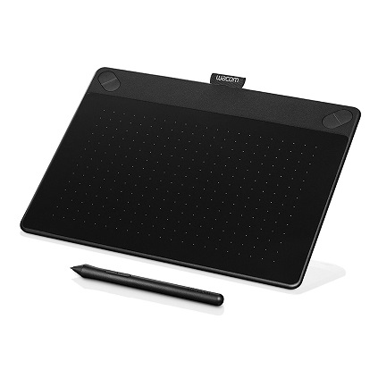
- – but technology can be cumbersome

Hardware for Inking on Documents
- Wacom Intuos Art Pen and Touch
- Medium size
- Digitizer tablet that provides pen (and touch) input to computer
- Can be connected to any computer
- $200

Typing or Inking in Word
- Use standard comments and “Track Changes” in “Review” tab
- Digitizer allows you to ink corrections and comments instead of typing them
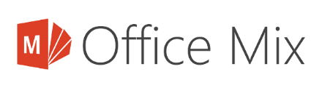
- Useful for grading papers, grading lab reports

Inking with Audio in PowerPoint
- Scan exams to digitize, then export from PDF to PowerPoint
- Use Office Mix add-in for PowerPoint
mix.office.com
  - Allows inking and audio to be synchronized
  - Removes any thought of or reference to video editing
  - Video is also possible
- Video-like media viewed by students on web
- Useful for grading exams

Grading in Student’s Presence
- Staggered homework turn-in times to allow 5-15 minute block per student
- Grade student’s assignments in front of them
- No easier way to provide effective feedback
- Useful for grading assignments

Inking Live in PowerPoint
- Digitizer can be used to ink slides live during lecture
- Useful for lecture

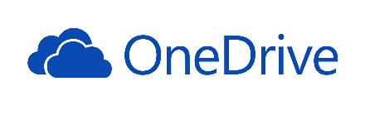
Cloud-based Collaboration through OneDrive
- Connected to TLU account on Office 365
- Tightly linked with MS Office
  - Full fidelity
www.office365.com
  - Full power of desktop office applications
  - Browser-based option
- Allows real-time collaboration
- Removes need to pass files back and forth
- Physics department uses are for senior seminar and reports for advanced labs

