Texas Lutheran University Degree Plan
Bachelor of Science in Biology
Student Name: _______________________ ID#: _________________________
Prospective Graduation Date: ________________ Catalog Year: 2023-24

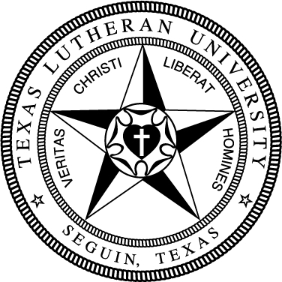

General Education
Take the following Foundation requirements (15 hrs):
Basic Quantitative Literacy
√ | MATH130 College Math or higher
Critical Reading
 | FREX134 Exploring the Arts & Sciences
Engaging Faith Traditions
 | THEO133 Intro to Theology
Modern Language
 | Foreign language at 131 level or higher *
Written Communication
 | COMP131 Composition I
 | COMP132 Composition II
* The language requirement can also be met by a study abroad program lasting 4 weeks.
Take the following Distribution requirements (24 hrs):
Arts 6 hrs
Humanities 12 hrs (no more than 2 courses/discipline)
Natural Sciences & Math 6 hrs (1 crs w/lab)
√ | BIOL 143 Biological Systems I
√ | CHEM 143 General Chemistry I
Social Sciences 6 hrs
Complete the following Competencies:
3 Critical Thinking Courses (T)
3 Engaged Citizenship Courses (Z)
2 Communication Courses (C)
1 Ethics Course (E)

IMPORTANT: An overall GPA of 2.0 and a major/minor GPA of 2.0 is required for graduation. All degrees require a minimum of 124 hours. It is the responsibility of the student to fulfill all degree requirements.
Student: ____________________________ Advisor: _________________________ Dept Chair: __________________________
Registrar: ______________________ Date: ___________________________

Biology-General (43 hrs)
BIOL 111 Biodiversity in Central Texas
BIOL 143 Biological Systems I
BIOL 144 Biological Systems II
BIOL 242 Microbiology
BIOL 331 Genetics
BIOL 338 Biostatistics
BIOL 340 Plant Biology
BIOL 428 Senior Capstone
One course from BIOL 332, 334, 430
Three courses from organismal biology/ecology:
BIOL 333, 336, 337, 431, 473
Two courses from molecular/cell:
BIOL 432, 433, 436, 437, 438, 471
Supporting coursework (24 hrs)
CHEM 143 General Chemistry I
CHEM 144 or 341 Gen Chem II or Analytical Chem
CHEM 248 Organic Chem I
MATH 241 Calculus I
8 hrs of Physics (141-142 or 240-241)
PHYS 141 or 240
PHYS 142 or 241
Electives or minor to total 124 hrs
Reflective Modules (3)
106

