Time to Huddle Up: Keeping Football Players in College
By Sean Bogle Jr., Emily Braun, Hannah Spears, and Tiffany Sia
Why we need better retention?
- Institution has tuition dollars for high quality academics and athletics
- The football team would have more seniors and a deeper bench (more depth)
- Students do not go deeply in debt, with no degree
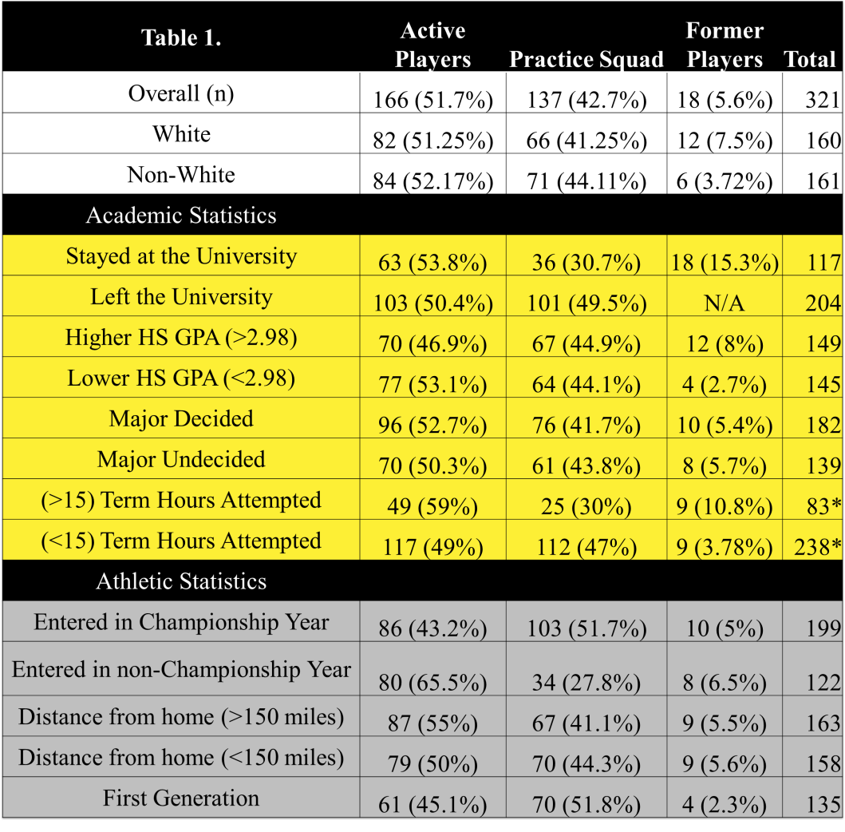
Current Characteristics of TLU football players from 2011 to 2015
Key Terms
Practice Players= players who do not travel but are on the JV team
Active Players= players who travel and are on the Varsity team
Former Players= players who played on either team and quit, but stayed at the University

HGPA= Players with a high school GPA above 2.98
LGPA= Players with a high school GPA below 2.98

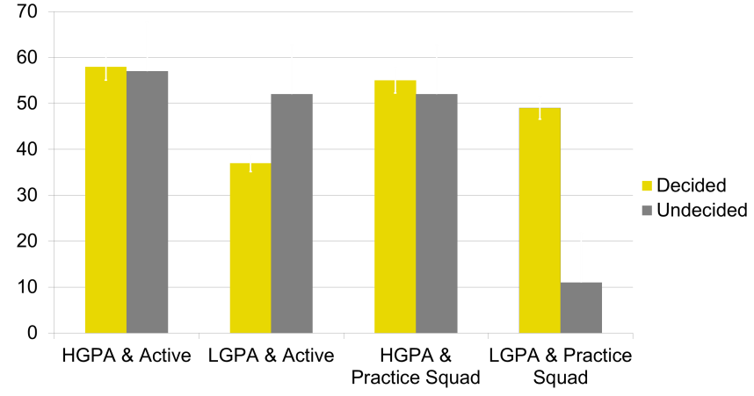
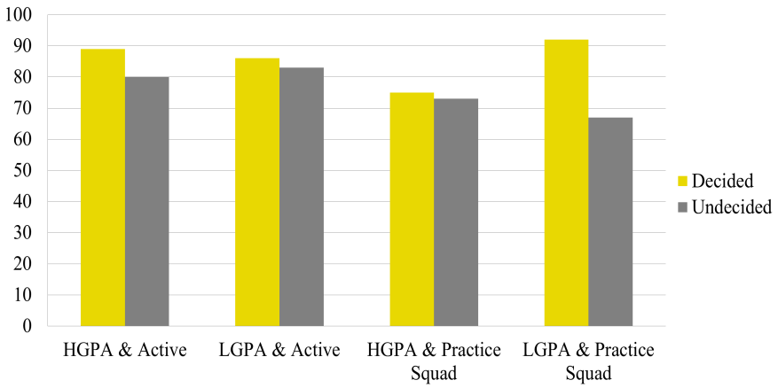
Factors that Make a Difference in retention
FALL TO FALL RETENTION

FALL TO SPRING RETENTION

Players, who were above the median split for a good high school GPA, had higher retention rates (56%) than those players who were below the median split for a good high school GPA (41%).
Players with a major had a higher retention rate (86%) than the undecided players (76%)
Biggest Misconception about TLU football players (Taking 15 hours will lose us players)

Significantly fewer members of the practice squad (73%) take 15 term hours than active players (86%) and former players (100%) who will leave football but stay at school
There is no difference in retention whether you take 15 term hours or not

What we are going to do about it
Step 1: Try out a Major
- Make incoming freshman choose a preliminary major during player check in
- Like any player, they can change majors
- This may keep them here for the second semester
Step 2: Study Hall to Win
- Specialized SI assistance during mandatory study hall for players at risk (below a 2.9 GPA)
- Math and Writing student instructors attending football’s mandatory study hall
- Training in making up assignments before missing the class with peer mentors or senior players
Step 3: 15 to Finish
- Make the incoming freshman players sign up for 15 course hours.
- Balance the workload (e.g. take Personal Wellbeing and an Intro course)
- Only withdraw after mid-terms if struggling
Talking Points
- Having a preliminary major helps you make friends and connections to the University
- Study is not punishment; it is here to help you be a better student-athlete
- If a player takes 12 hours during season by their sophomore year, they will need to take an extra semester to graduate with the required 124 hours.
- Federal financial aid runs out after 4 years putting players at an unfair disadvantage to graduate or be in debt.
How do we make this plan better?
Email: sabogle@tlu.edu & tsia@tlu.edu Phone: 281-900-3181

