Texas Lutheran University Degree Plan
Bachelor of Arts in Chemistry
Student Name: ____________________________ ID#: _________________________
Prospective Graduation Date: ________________ Catalog Year: 2021-22

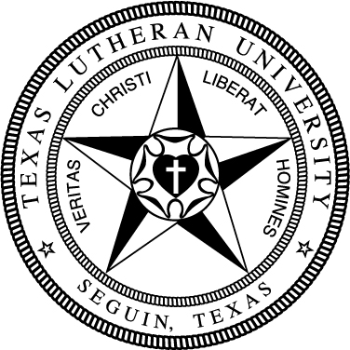

General Education
Take the following Foundation requirements (15 hrs):
Basic Quantitative Literacy
√ | MATH130 College Math or higher
Critical Reading
 | FREX134 Exploring the Arts & Sciences
Engaging Faith Traditions
 | THEO133 Intro to Theology
Modern Language
 | Foreign language at 131 level or higher*
Written Communication
 | COMP131 Composition I
 | COMP132 Composition II
* The language requirement can also be met by a study abroad program lasting 4 weeks.
Take the following Distribution requirements (24 hrs):
Arts 6 hrs
Humanities 12 hrs (no more than 2 courses/discipline)
Natural Sciences & Math 6 hrs (1 crs w/lab)
√ | CHEM 143General Chemistry I
√ | PHYS Elective
Social Sciences 6 hrs
Complete the following Competencies:
3 Critical Thinking Courses (T)
3 Engaged Citizenship Courses (Z)
2 Communication Courses (C)
1 Ethics Course (E)

IMPORTANT: An overall GPA of 2.0 and a major/minor GPA of 2.0 is required for graduation. All degrees require a minimum of 124 hours. It is the responsibility of the student to fulfill all degree requirements.
Student: ____________________________ Advisor: _________________________ Dept Chair: __________________________
Registrar: ______________________ Date: ___________________________

Chemistry (38 hrs)
CHEM 143 General Chemistry I
CHEM 144 General Chemistry II
CHEM 248 Organic Chemistry I
CHEM 332 Intermediate Inorganic Chemistry
CHEM 341 Analytical Chemistry
CHEM 344 Physical Chemistry I
CHEM 434 Biochemical Principles
10 hrs from the following In-Depth field:
CHEM 122 Intro to Research Methods
CHEM 249 Organic Chemistry II
CHEM 342 Instrumental Techniques
CHEM 345 Physical Chemistry II
CHEM 379 Special Topics
CHEM 414 Physiology/Biochemistry Lab
CHEM 435 Medicinal Chemistry
CHEM 436 Environmental Chemistry
CHEM 437 Metabolic Biochemistry
2 hrs of Senior Seminar:
CHEM 411 Senior Seminar I
CHEM 412 Senior Seminar II
Supporting coursework (28 hrs)
PHYS Elective
PHYS Elective
MATH 241 Calculus I
MATH 242 Calculus II
12 hrs (9 hrs at 200-level or higher) from math (not MATH 375-376), physics, computer science, STAT 374 or BIOL 341, BIOL 414, BIOL 431, BIOL 432 or BIOL 444
Electives or minor to total 124 hrs
Reflective Modules (3)
105

